Standard Operating Procedure for Older Person’s Care Home Contract
Service Area: Adult Social Care

Senior Responsible Officer: | Sarah Mackereth. Head of Quality, Performance and Re-design
Author: | Care Homes Contract Project Team.
Version and date: | V 1.0
Approved by: | POP Group
Approval date:
Reviewed date:

Record of Amendments
Date | Paragraphs/pages amended

- Purpose of this Standard Operating Procedure (SOP)

The SOP has been developed to support the implementation of the new ‘2025 Pre-Placement Agreement’ for care homes in Devon.

All Devon based providers (excluding Torbay, Plymouth and out of county) who wish to continue to work with DCC, must accept and sign up to this pre-placement agreement.

Alongside the 2025 Pre-placement Agreement, the previous Personalised Fee Model and RAS system is replaced with a new Older Persons Care Home Fee Model, for all long and short term residential and nursing placements, and all Section 117 placements for older people. This will mostly relate to people aged 65 and over, and some working age adults for whom needs can be most appropriately met in an Older People’s Care Home.

This SOP sets out the required actions and principles for practitioners to assess and arrange placements in older person’s care homes.

It ensures consistency, transparency, and clarity in our processes and will ensure that practitioners take the correct steps, and providers understand what to expect.

For further details DCC operational teams should refer to the main Care Homes Staff Guidance. All About Residential & Nursing Care.

2. Objectives

This SOP applies to all staff involved in assessment, arranging and monitoring care home
placements for older people.

The SOP will:
- Drive best practice, the quality of decision making and improvement through a review of needs, risks, eligibility, and support options,
- Ensure that the principles of DCCs Fair and Affordable, Promoting Independence, and Choice Policies are followed.
- Increase consistency of approach across Devon
- Ensure decisions are recorded appropriately on our case recording system.

3. Foundation of good Practice

We always demonstrate our Practice Standards and Values within our work and we
apply a strengths-based approach through our Empowering lives through 3conversations approach.

4. Assessing and arranging Older Peoples Care home placements
Staff must follow these steps when assessing and arranging a care home placement:

4.1 Supporting Assessment and Placement Detail:

When the Practitioner receives a request for a Care Act Assessment this may come through:
- A community route
- A person via hospital discharge pathway where there are ongoing care needs and a perception of need for care, in a residential/nursing environment
- A review where the person’s needs have increased.

Throughout the process the Practitioner must ensure timely communication with the person, family/carers and current provider/s.

New Client from the Community (Residential)
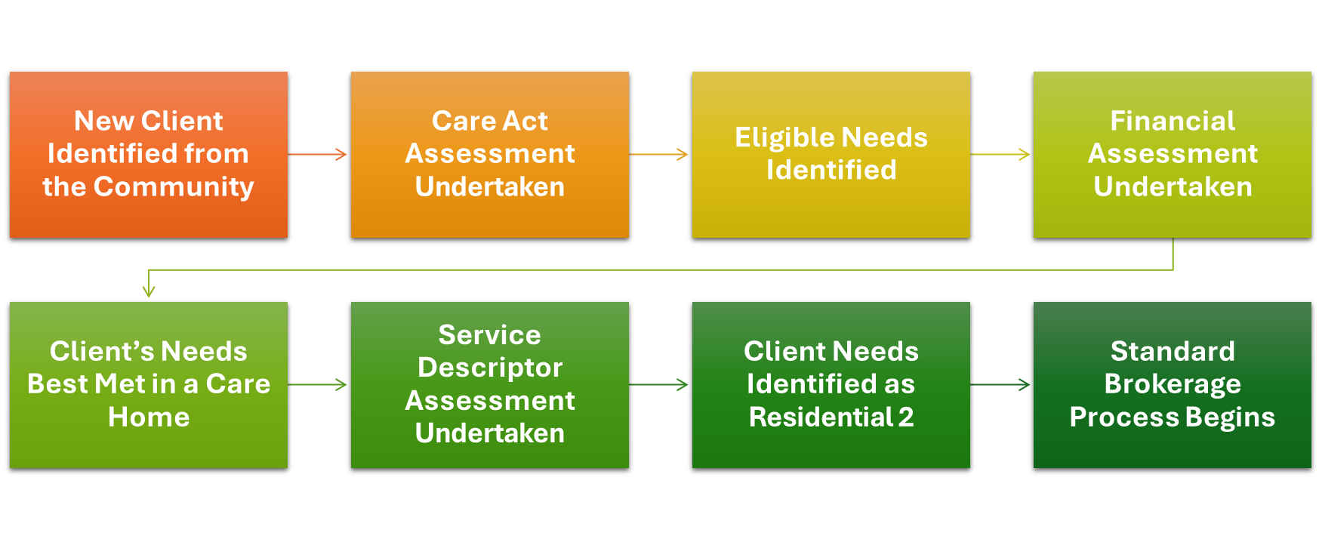The Practitioner will assess the person’s needs and to determine eligibility for care and support; this will include information from the provider/s, where the person is currently in receipt of care and support.

- Practitioner will assess the best way to meet those needs i.e. Care home placement (after considering all alternative options).
- Practitioner will trigger financial assessment when we need to provide a service, funding and confirm placement details.
- Practitioner uses the Service Descriptor 11 core areas to determine the appropriate Service Descriptor level and overall level of care.
- Practice Quality Forums (PQFs) will review the proposed Service Descriptor level and provide recommendations for further review or consideration of other services or preliminary agreement about how needs are best met and that the service descriptor framework has been correctly applied.

Standard Brokerage Process
- Arranging Support Team (AST) – go to market, identify suitable care home options.
- AST share offers of placements (at the service descriptor rate) with the Practitioner.
- Practitioner discusses options with individual/family and identifies preferred option.
- Practitioner confirms preferred option to AST.
- AST engage with providers and confirm placement availability and start.
- Practitioner ensures communication with person, family, and provider where appropriate.
- Practitioner and then AST ensure that the Your Care and Support Plan (YCSP) is finalised and sent to the provider and to the person.
- Practitioner ensures that all steps and decisions are recorded in the case management system.

Client Reviews
- Practitioner completes 6–8-week (light touch) review.
- Practitioner schedules the annual review.
New Client from the Community (Nursing)

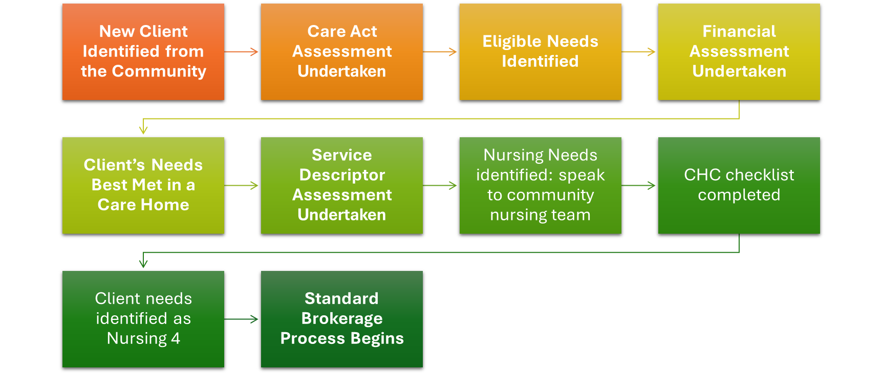

The Practitioner will assess the person’s needs and to determine eligibility for care and support; this will include information from the provider/s, where the person is currently in receipt of care and support.

- Practitioner assesses the best way to meet those needs i.e. Care home placement (after considering all alternative options).
- Practitioner to trigger financial assessment when we need to provide a service, funding and confirm placement details.
- Practitioner uses the Service Descriptor 11 core areas to determine the appropriate Service Descriptor level and overall level of care.
- The need for nursing care is identified (i.e. nursing needs are such that 24/7 and oversight from a registered nurse, where needs can’t be safely met by visiting community nursing team) the Practitioner must seek confirmation from community nursing team.
- Practitioner considers NHS input as required, including CHC process.
- Practice Quality Forums (PQFs) will review the proposed Service Descriptor level and provide recommendations for further review or consideration of other services or preliminary agreement about how needs are best met and that the service descriptor framework has been correctly applied.

Standard Brokerage Process
- Arranging Support Team (AST) – go to market, identify suitable care home options.
- AST share offers of placements (at the service descriptor rate) with the Practitioner.
- Practitioner discusses options with individual/family and identifies preferred option.
- Practitioner confirms preferred option to AST.
- AST engage with providers and confirm placement availability and start.
- Practitioner ensures communication with person, family, and provider where appropriate.
- Practitioner and then AST ensure that the Your Care and Support Plan (YCSP) is finalised and sent to provider and to the person.
- Practitioner ensures that all steps and decisions are recorded in the case management system.

Client Reviews
- Practitioner completes 6–8-week (light touch) review.
- Practitioner schedules the annual review.

Long Stay Residential or Nursing Client Reviews

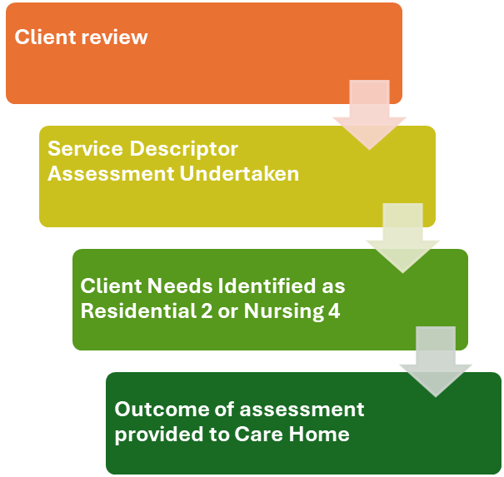

The Practitioner will review the needs long-stay client in a residential care home to determine eligibility for care and support; this will include information from the care home provider.

- Practitioner uses the Service Descriptor 11 core areas to determine the appropriate Service Descriptor level and overall level of care.
- Practice Quality Forums (PQFs) will review the proposed Service Descriptor level and provide recommendations for further review or consideration of other services or preliminary agreement about how needs are best met and that service descriptor framework has been correctly applied.
- The Care Home provider and person will be informed of the outcome of the assessment.
- The Your Care and Support Plan will be updated and shared with the Home and person and the new service agreements applied.

Practitioner will complete a risk assessment for any potential move where the need arises, e.g. where the care home has not signed the contract, and will identify if it is safe to move the person.

4.2 Targeted Support:

Targeted Support may apply if there is a significant escalation in care needs impacting across several of the service descriptors categories, and a clear escalated risk of harm to the individual or others.

A health professional must be consulted; and the care team must first explore all options for alternative support (Technology Enabled Care and Support (TECS) etc) to reduce risk.

Targeted support will be time limited and cannot continue beyond the contracted period without review and further agreements.

Authorisation is initially via Practice Quality Forum (PQF) with final approval through the Older Persons Fee Model Enhanced Authorisation Process (EAP).

The Care Home Provider must record behaviour diaries to evidence all events of escalated harm to the individual or others.

4.3 Bespoke care arrangements:

Bespoke care arrangements may apply where the person’s long term care needs exceed those described in the Service Descriptors across multiple areas.

Authorisation is initially via PQF and with final approval through the Enhanced Authorisation Process. For new clients this will trigger an approach to the market for a bespoke care agreement via AST using an Expression of Interest Form (EOI) and pricing template.

For existing clients, the Care Home provider will complete the Long-Term Bespoke Review Form and pricing template which will be reviewed by EAP. Further details of these two processes are detailed in the next section.

Bespoke Care Arrangements New client from the community, following HD or in a Care Home that can no longer meet needs of the client.

The Practitioner will assess the person’s needs and to determine eligibility for care and support; this will include information from the provider/s, where the person is currently in receipt of care and support.

- Practitioner assesses the best way to meet those needs i.e. Care home placement (after considering all alternative options).

- Practitioner triggers financial assessment when we need to provide a service, funding and confirm placement details.

- Practitioner using the Service Descriptor 11 core areas determines that the persons needs are above those detailed in the Service Descriptors.

- Practice Quality Forums (PQFs) will review the proposed Service Descriptor level and either provide recommendations for further review or consideration of other services or preliminary agreement about the persons needs are above those detailed in the service descriptors and that the service descriptor framework has been correctly applied.

- The assessment is reviewed via the Older Persons fee model Enhanced Authorisation Process (EAP).

- EAP agree that the persons needs are above the Service Descriptors and the brokerage process begins.

Bespoke Brokerage Process

- AST will jointly create the Expression of Interest Form (EOI) with the practitioner which AST then sends out to the market countywide.
- Care home providers return the EOI within 2 working days.
- AST check and question where appropriate price elements, then forward options to Finance to check costings and to the Practitioner.
- Practitioner returns the case to EAP to decide on the best value offer
- The best value offer(s) are sent to the Practitioner to discuss with the person and/or family (in the event of more than one best value option being available)
- The person/family agree placement and the person moves.

Client Reviews
- Practitioner completes 4-week review.
- Practitioner schedules the annual review.

Bespoke Long Stay Client Review Process

The Practitioner will review the person’s needs this will include information from the provider.
- Practitioner using the Service Descriptor 11 core areas determines that the persons needs are above those detailed in the Service Descriptors.
- Practice Quality Forums (PQFs) will review the proposed Service Descriptor level and either provide recommendations for further review or consideration of other services or preliminary agreement about the persons needs are above those detailed in the service descriptors and that the service descriptor framework has been correctly applied.
- The assessment is reviewed via the Older Persons Fee Model Enhanced Authorisation Process (EAP).
- EAP agree that the persons’ needs are above the Service Descriptors, the Practitioner completes Part A of the Long-Term Bespoke Review Form and sends with Part B of the Form with the pricing template to the current provider to complete.
- The provider returns Part B and pricing within 2 working days to the Practitioner who sends to EAP and the pricing elements are sent to finance
- Practitioner returns the form to EAP to decide whether the offer is best value.
- If agreed, the offer is sent to the Practitioner and AST for the new agreement to be put into place with the Care Home provider.
- If the offer is not agreed by EAP then the Bespoke EOI process detailed above will be utilised.

5. Monitoring and Reviews
Once a placement is made, practitioners must ensure ongoing monitoring and timely reviews:
- Schedule an initial “Light touch” review at 6-8 weeks.
- Where targeted support is in place, schedule checks/reviews prior to the end of time-limited support.
- Schedule Care Act Review.
- Respond to a request from a provider for expedited review where there is clear evidence supporting a change in need.
- Communicate clearly with providers and families during reviews or moves.

Providers may request an early or expedited review where there is clear evidence of a person’s needs having changed or escalated beyond the contracted level of care.
Provider gives clear evidence which supports that this is not a short term or temporary escalation. This may be considered as requiring targeted support.

6. Third Party Top Ups and Deferred payments
Care Act Guidance (Annex A, section 20) allows for a person to choose a setting that is more expensive, where there is a third party able to pay a top up.

Where deferred payment is in place the individual may be able to offer a first party top up.

The care home must have signed up to the 2025 care home pre-placement agreement.
The additional charge must reflect only premium charge/costs relating to elements such as room size or aspect.

If a top up is applied, a written top up agreement – signed by the third party – must be in place.

The role for social care practitioners is to signpost the person to the relevant guidance and help to ensure that the person and the third party understand the requirements.

This includes the commitment to pay the top up for the foreseeable future and understanding that the person may need to move if the top up cannot be sustained.

All top ups must be agreed upon between DCC, the specified care home, the person and/or the third party. They are paid direct to DCC who then pays the care home the full amount.

The Top Up policy, along with the letter and agreement template can be found here

7. Provider communication routes:
- Providers should ensure that contact details are up to date regarding placements, finance and contracting queries.
- Link with Arranging Support Team to offer placement in response to invitations to tender, including clarifying any elements of the support offer;
- Work with the assessing practitioner to share information about needs and support arrangements; and at the point when a placement is agreed/confirmed to support any move-in arrangements.
- Link through Care Direct Plus (CDP) for requests to review in response to changes in need, providing clear evidence.

8. Raising Concerns
If a provider wishes to raise concern about any element of DCC practice and adherence to steps in this process, this should in the first instance be raised with the Manager of the Team member concerned.

Escalation beyond the immediate Team Manager would be to Community Services Manager for community teams, and Centre Manager for CDP Teams.
Appropriate contact details are provided in appendix one.

9. Funding and Financial Guidance
Staff should be familiar with financial procedures related to placements: Policies and procedures
- Charging Policy for Residential Care Services for Adults - Adult social care
- Policy on support and arrangements for people funding part or all of their care - Adult social care
- Eligibility for adult social care and support - Adult social care
- Deferred Payment Agreements Policy - Adult social care
- Financial Top Ups for Residential Care – Policy Guidance - Adult social care
- Fair and Affordable Care Policy - Adult social care

Appendix One
Contact details

Appendix Two
Three conversations model

